Learning Goal
Pivoting my portfolio design and development in a new direction.
Action
Starting from the second week of the semester, I began designing my portfolio. After researching other portfolios, I decided to create an interface similar to YouTube’s, where my learning outcomes and projects would be displayed as "videos" with the documentation shown in the comment section. I received positive feedback on the initial concept and began coding it using HTML, CSS, and JavaScript. I laid out the base structure, added a few learning outcomes, and implemented small JavaScript animations.
To get further feedback, I presented the portfolio to Stan, the teacher who oversees most of our JavaScript classes. While the code and design were solid, he pointed out that the YouTube interface might be too common and doesn’t align with the objectives of a personal portfolio. He suggested I aim for a more impactful design, given my capabilities.
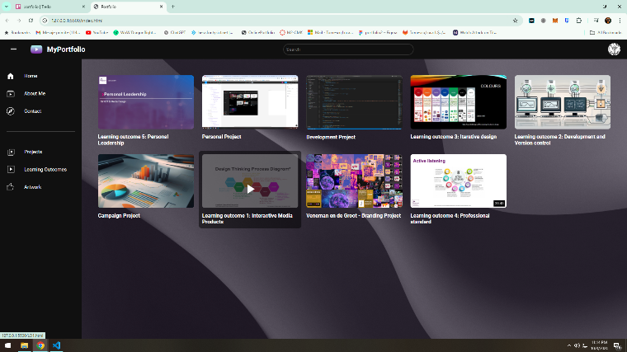
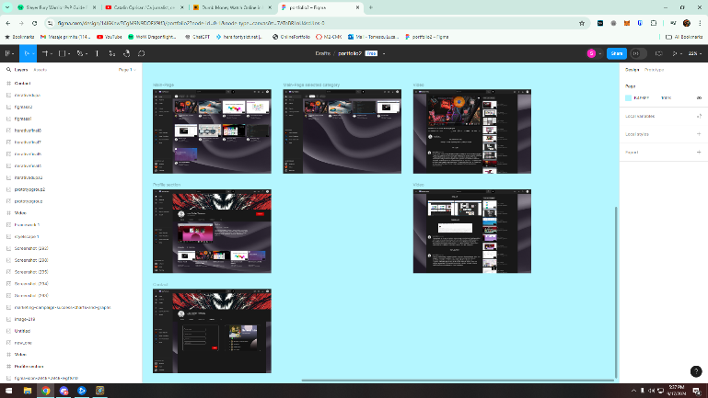
Reflecting on that feedback, I spent the next weekend redesigning my portfolio. I pivoted to a 3D space theme using Three.js, featuring static and moving stars, a planet, and two constellations that represent learning outcomes and projects. The user can navigate through the space with keyboard and mouse controls, and there’s a menu for switching between the main planet and the constellations.

Result
The new portfolio, with its immersive space theme and interactive elements, was well-received when I showcased it. The feedback was largely positive, with appreciation for the unique, creative approach. The 3D navigation system and visual representation of learning outcomes and projects made the portfolio stand out. However, it was noted that I still needed to find a more effective way to display the learning outcomes examples.
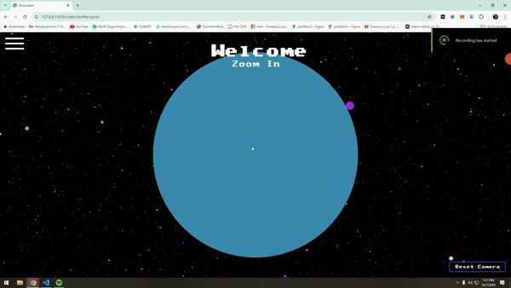
Feedback
The feedback I received was encouraging. The teacher appreciated the originality of the new design and the technical complexity of the space interface. The interactive features and navigation system were seen as engaging and well-implemented. The main suggestion was to think more about how I could better present the actual content, particularly the learning outcomes, within this new format. 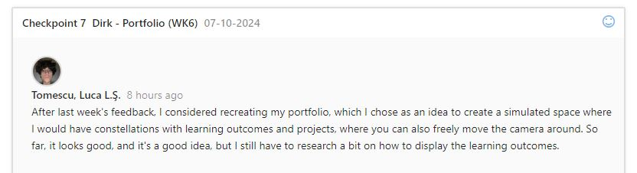
Reflection
This experience highlighted how crucial it is to align design choices with the portfolio's purpose and to push beyond common solutions. Initially, I gravitated toward a familiar interface, but the feedback helped me see the value in taking a more unique approach. Reflecting on the shift, I realized the importance of balancing creativity with functionality and ensuring the design effectively showcases the content, not just the visuals.
Decide
In the future, I will aim to create portfolio designs that are both innovative and highly functional. I learned that it’s important to be open to feedback, especially when it challenges my initial ideas, as it can lead to more impactful results. I will continue iterating on the content presentation within my current portfolio, focusing on how to clearly and effectively display learning outcomes and project details in an engaging way.

